Guidelines on Blender Animation for Parrot FBX Export

During editing in blender:
Under “Nonlinear Animation” section,
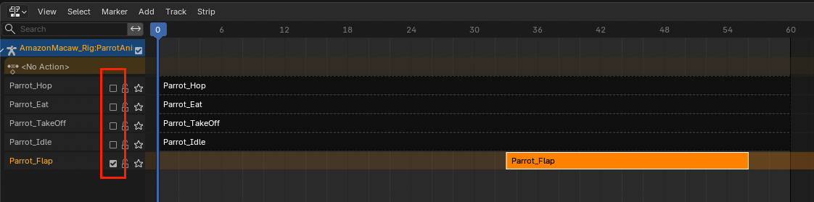
- Toggle OFF other NLA strips that are not in edit, so it will not influence previews in Blender.

Before Export:
Under “Nonlinear Animation” section,
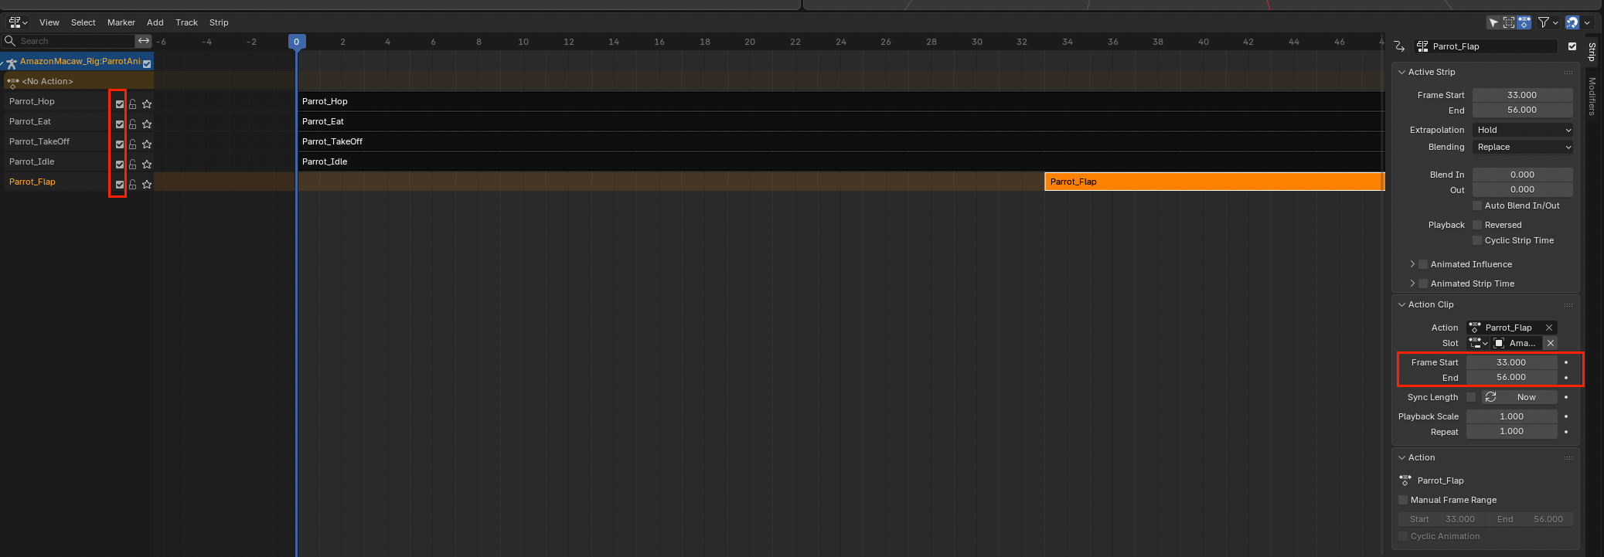
- Toggle ON all NLA strips.
- If need, clip NLA strip under “Action Clip” panel.

Under Export > FBX panel,
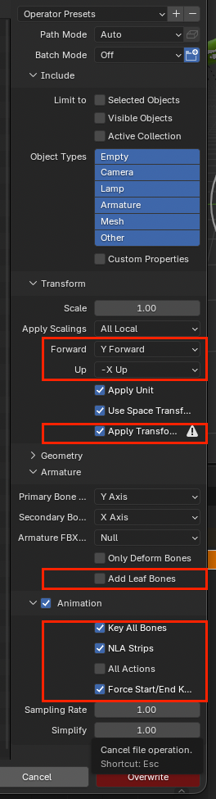
- For this particular model, set Y Forward and -X Up.
- Check Apply Transformation
- Uncheck Add Leaf Bones
- Check Key All Bones
- Check NLA Strips
- Uncheck All Actions
- Check Force Start/End Key…

